Instructions for running City Recommandation System,

**Database:**

1. install mysql on the your machine.
2. Import yelpDB database to mysql, using mysql command

|  |
| --- |
| mysql -u [username] -p database_name < yelpDB.sql |

1. Change the username and password where jdbc get authenticated to mysql:

|  |
| --- |
| …/CityRecommandation/Processing/queries/Query.java |
| Modify the username and password |

**Web Server Environment setting**

1. Apache Tomcat

install Tomcat on your machine, reference:

<https://tomcat.apache.org/tomcat-7.0-doc/appdev/installation.html>

2. Copy two jar files our application references into bin folder under your Tomcat folder:

|  |
| --- |
| gson-2.2.2.jar |
| mysql-connector-java-5.1.37-bin.jar |

1. Import the project by” import existing project into workspace”

(If you get many “The superclass "javax.servlet.http.HttpServlet" was not found on the Java Build Path“ errors, you need to add your apache tomcat to this project by adding a new runtime :

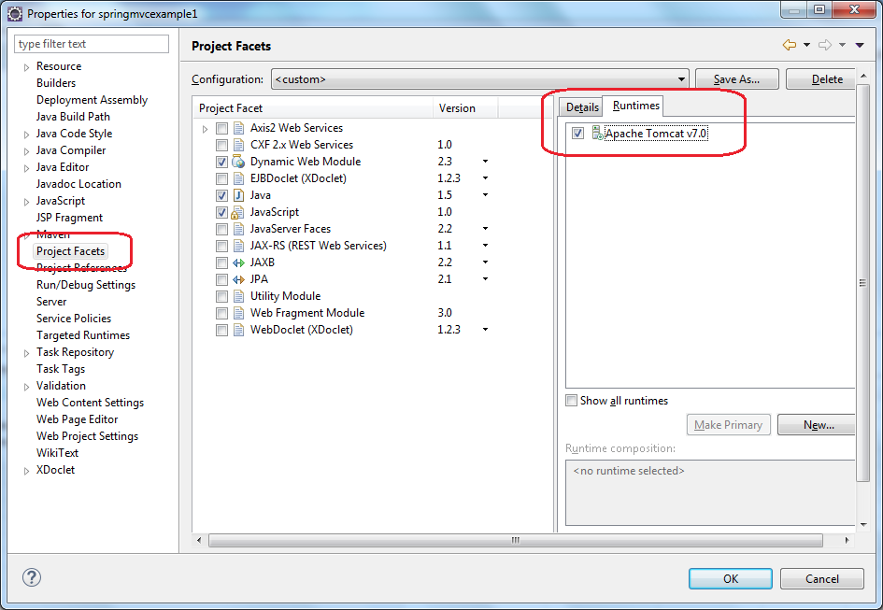

)

Then in the”Webcontent/index.jsp”, right click , and choose “run on server”